**OBJECTIVE**

Data Structures

Unity

Android Studio

Blender

**TECHONOLOGIES**

**AKASH RANJAN**

Chennai

Hindi

**EDUCATION**

**Problem**

**solving**

**INTEREST & HOBBIES**

Room no-07, Vaagai Hostel Anna University, Chennai, Tamil Nadu - 600025.

Chennai

Bokaro

Bokaro

Durgapur

Chennai

**Graphic Design**

**3D-M**

**Photography**

**10th | 2012 | The Pentecostal Assembly School, CBSE**

Score: 7.2 CGPA

**MCA | Pursuing (2021) | CEG, Anna University**

Score: 8.71 CGPA (Till 4th Sem.)

**BCA | 2017 | Dr. B C Roy Engineering College, MAKAUT**

Score: 7.34 CGPA.

2020

English1

**12th | 2014 |Sree Ayyappa Public School, CBSE**

Score: 64.20 %

2012

2012 - 2014

2014 - 2017

Present

**Achievement 1**  (July 2018)

**AIR – 16** (TANCET)

**LANGUAGES KNOWN**

**SKILLS**

**ACHIEVEMENTS**

Core Java

DBMS

ranjan.akash60@gmail.com

+91 7352770747

Birthday

**2.12.1995**

Experience

**Fresher**

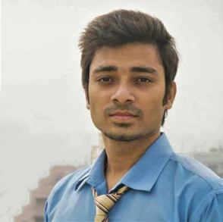To get a growth oriented position in a reputed organization where my skills can be utilized for improvement and success of the organization.

**PHARMACY MANAGEMENT SYSTEM**

**Environment:** Netbeans, Java, DBMS

**Project Description:** PMS is used to manage medicines in a pharmacy store (Manage Stock and Customer).

**MESSAGE STATUS**

**Environment**: Android Studio, Java

**Project Description:** SMS sending and receiving (to receiver) notification to sender without using internet.

**PROJECT DONE**

2019

**EDITORIAL TEAM MEMBER, CEG, ANNA UNIVERSITY**

**Environment:** Adobe Photoshop, Adobe Illustrator, MS Publisher

**Work Description:** Made Information Brochure for the college.

2020

**EXPERIENCES**

**DECLARATION**

I hereby declare that all the above mentioned details are true to the best of my knowledge.

AKASH RANJAN